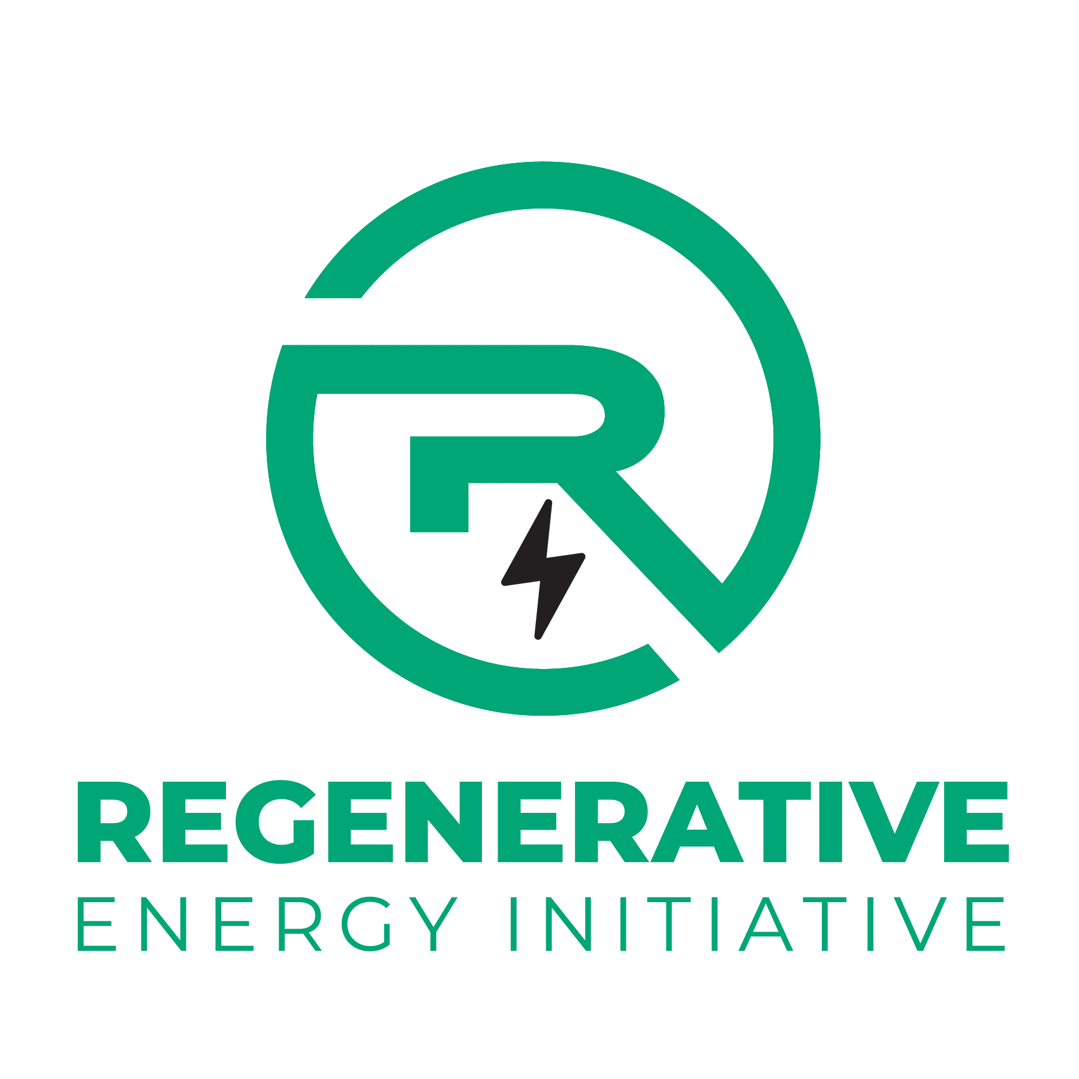
Request for Qualifications & Expressions of Interest
Energypath Bootcamp Instructors
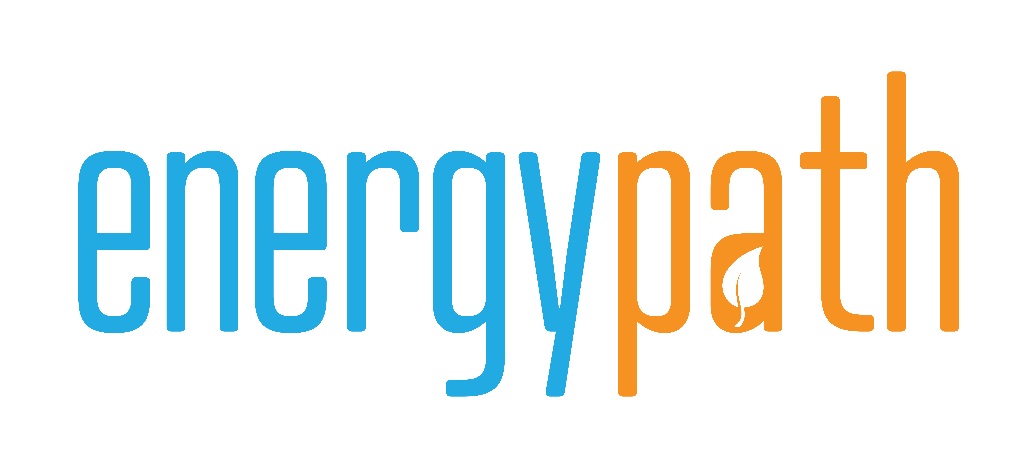

Presented By:
Regenerative Energy Initiative
October 1, 2026
Deadline: October 31, 2026

The Regenerative Energy Initiative was established in 1999 as part of a settlement approved by the PA Public Utility Commission. Regenerative Energy Initiative is a non-profit 501(c)(3) organization that promotes energy efficiency, renewable energy and energy education throughout the Commonwealth of Pennsylvania.
Purpose
Regenerative Energy Initiative invites statements of qualifications and expressions of interest from contractors, training providers, and individual instructors interested in developing and delivering a three-day training on selected renewable energy topics for college students and educators with varying levels of knowledge.
The purpose of this request is to assess interest, identify relevant expertise and instructional capabilities, and inform future program planning. Respondents are encouraged to describe their experience, potential training topics, and capacity to provide engaging, hands-on instruction.
This is a preliminary information-gathering request, not a request for proposals or pricing. A detailed curriculum and cost proposal are not required at this stage. No contract will be awarded through this request, and participation does not guarantee future work. Regenerative Energy Initiative may issue a separate solicitation after reviewing responses and refining the training scope.
The topics below reflect our areas of interest, but it not exhaustive. Respondents are encouraged to propose additional sustainable, renewable, and regenerative energy topics that would complement Energypath programming.
- Intro to Solar Photovoltaics (PV)
- Intro to Biomass, Bioenergy, or Biogas
- Intro to Energy Efficiency
- Intro to Energy Storage and Batteries
- Intro to Microhydro
- Intro to Energy Policy
- Intro to Passive House/Passive Building

Background of Energypath
Energypath is the largest educational program of the Regenerative Energy Initiative. The goal is to develop an understanding and passion for sustainable energy in the leaders of tomorrow. Energypath is a multi-day seminar that provides hands-on training in renewable energy and energy-efficiency technologies. We provide up to 100 attendance scholarships for students, secondary educators, and post-secondary educators. The Regenerative Energy Initiative covers lodging, food, and training materials through donations, sponsorships, and grants.
In 2005, we started our award-winning Solar Scholars® program, where Regenerative Energy Initiative would send one college to Colorado for training on solar photovoltaic systems. In 2008, we hosted 30 student/instructor teams at Dickinson College. Our 2009 event was housed at Lafayette College and included more than 100 scholars. In 2009, we began offering pre-conference boot camps in solar photovoltaic, solar thermal, wind energy, and energy efficiency.
In 2026, we hosted boot camps again for the first time since the COVID-19 pandemic. Energypath 2026 was held at Moravian University in Bethlehem, Pennsylvania, providing bootcamps including energy efficiency, solar photovoltaics, bioenergy, and energy policy.

Instructor(s) Scope and Qualifications
When: Summer 2027
Where: A University in the Lehigh Valley
What: A 3 or 4-day career readiness training course or “boot camp.” Teaching would take place for approximately 8 hours a day. Teaching can include classroom instruction, hands-on training, labs, and field trips where appropriate.
Regenerative Energy Initiative will provide boot camp instructors with housing and meals.

Submission Requirements
Please provide the following contact information and answers to the six questions below.
Deadline: October 31, 2026
Format: PDF or Word document
Send to: info@energypath.org
Name:
Company/Institution Name:
Address:
Telephone #:
Email:
Energypath Bootcamp subject:
Professional Licenses, Current (if any):
Certifications (if any):

- Describe your education/experience that qualifies you as a subject matter expert for the Energypath Boot Camp?
- What is your teaching experience?
- Have you ever taught in a structured environment? Is yes, what, when, and where?
- Do you have the ability to adapt to a hands-on teaching environment? If so, how?
- Have you ever offered off-site training?
- If so, can you provide a sample agenda or existing instructional material?

